**COSC 310 Assignment 3**

**Philip Okanlawon**

**Repository Link:** <https://github.com/philyfwik/Charles-the-ChatBot>

Sample Output

* Video called “Charles Convo” shows successful conversation with 30 turns

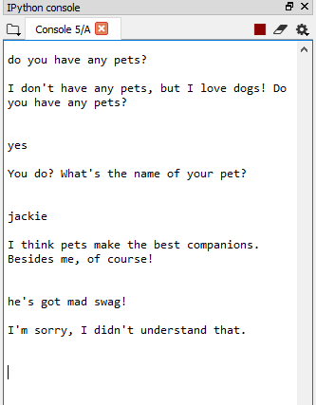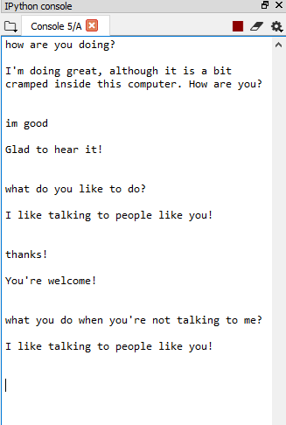

* 2 different dialogues showing chatbot’s difficulty handling conversation properly (above)

Limitations

* `convo.dat` file must begin with an empty line, and end with two empty lines.
* First 2 topics of convo.dat must be default statement response and default question response, respectively.
* Correlation algorithm likely won't scale well when many more topics are added.
* Doesn't handle context well; user must explicitly mention what they're referring to each time they ask a question.
* Can't both save an answer and determine the positivity of a single user response.
* If the `+` operator is used, the next 3 lines MUST start with each one of `+`, `-`, and `0`.

Shareable Features

Features that can be extracted and shared with others as an API:

* GUI
* Spellchecker
* Parts of speech / grammar understanding
* Sentiment analysis
* Determining topic of discussion

Level 0 DFD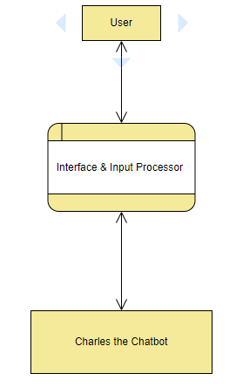

Level 1 DFD

